Entity Description, Business Rules, ERD and EERD of Project

Department of Computer Systems Engineering

University of Engineering and Technology, Peshawar

Lab Report # 05



Spring 2020

CSE 403-L—Database Management Systems--Lab

Submitted by: Muhammad Asif Ayub

Assad Ullah Khan

Registration No: 17PWCSE1508

17PWCSE1558

Class Section: A

“On my honor, as student of Engineering and Technology, I have neither given nor received unauthorized assistance of this academic work”.

Student Signature:

Submitted to:

Engr. Naina Said

Wednesday, June 17th, 2020

Entity Description, Business Rules, ERD and EERD of Project



-:Entity Description:-

These are the following Entities we are using in our project.

* **Customer:-**

Customer is a person who is going to order or just a visitor to our website like for example: student, person may be male/female, but they must provide CNIC for order confirmation and placement within the same city.

* **User:-**

Could be a manager an administrator or business owner who can manage customers, orders, food items and category. User can also modify, delete, edit, or create new food item in admin panel/dashboard.

* **Orders:-**

Order contains products/food items that is ordered by specific customer which contains status, date time etc.

* **Food:-**

Food is contained in multiple categories it contains multiple food items with multiple attributes as shown in the ERD.

* **Food_Image:-**

Contains images of all food items.

* **Category:-**

One Category contains multiple food items and there are multiple categories like for example Chinese food is a category and spaghetti, rice, chowmian etc. are food items.

* **Delivery:-**

In order status we have two option Home delivery or Take Away for take away there is no need to make extra entity which can be handled in order entity.

Orders can be delivered to any place within the city with fix any location charges.

* **Payment:-**

Orders payment can be performed at counter with 0 delivery charges as well as at Cash on delivery service as well.

-:Business Rules:-

Following are the business rules we have specified for our business.

* CUSTOMER may submit optional many ORDERS. Conversely ORDERS can be submitted by exactly one CUSTOMER.

For example: Muhammad Asif Ayub ID:1210157236327 submitted Order_No:102 Chicken Biryani Price: 350.

* User is a Person who can manage Customers, Orders, Food items and categories along with payments and delivery status.
* Every ORDER has mandatory single PAYMENT; however each PAYMENT is for exactly single ORDER placed by CUSTOMER.
* ORDERS have optional single DELIVERY or ORDER may be TAKE AWAY. Conversely Each DELIVERY may have multiple ORDERS to be delivered to different CUSTOMERS.
* Every ORDER contains at least one FOOD item associated with ORDER DETAILS. Furthermore, Each FOOD item may be in many ORDERS Associated with ORDER DETAILS.
* We have different CATEGORIES of food items. Each category contains many FOOD items while each FOOD item belongs to only single category.
* Each and every food item has image where an image belongs to only one food item.

-:Entity Relationship Diagram:-

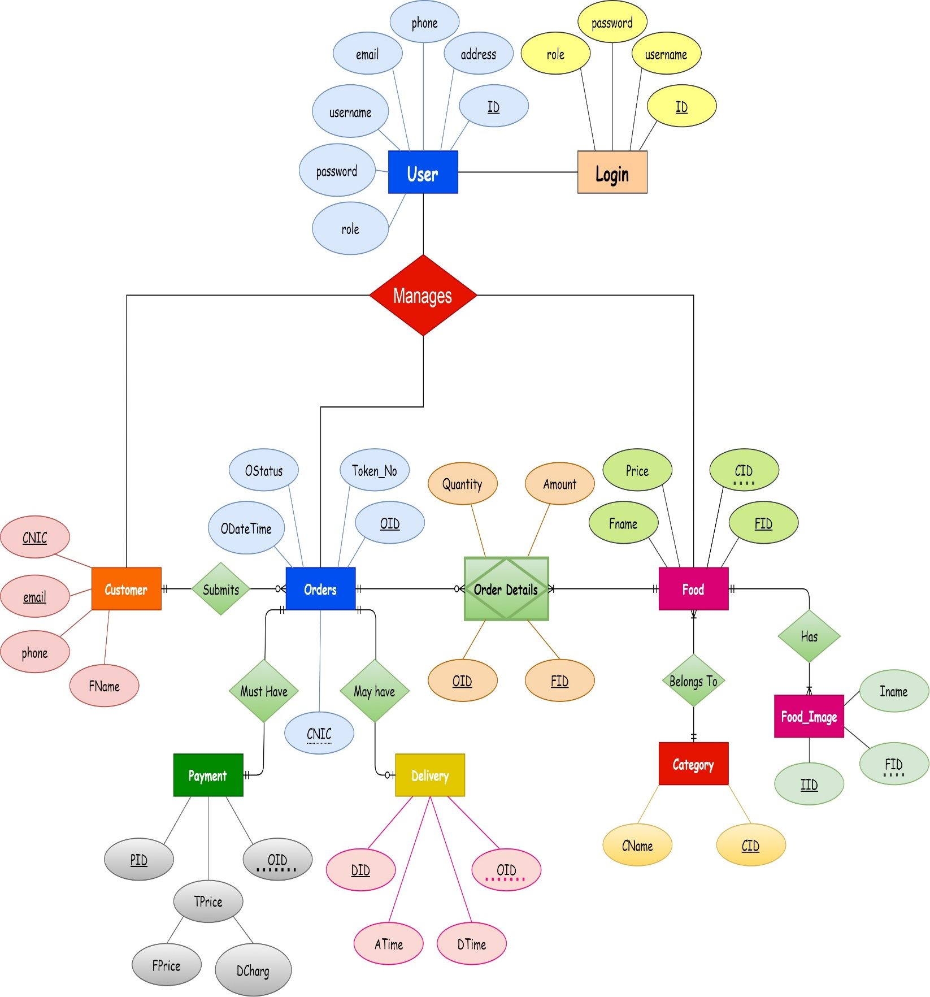

-:Normalized Relational Schema:-

